What is react??

React calls itself a javascript library that allows us to create interfaces. Interfaces are the basic building block of react.

React allows us 1)Display HTML 2)Dynamically change that HTML

So we can create and display HTML according to our logic and change the html,which is basically the view of the application

based on user input,some logic,etc.

JSX

it is javascript XML.It allows us to write HTML and Javascript together.This is done with the intention of having logic and UI work along to some extent.

Components

They are functions that tell react what to show on the screen.These function return jsx as return value.A project has many components working together. We need to think in terms of components during development process

ROOT

When we see our html file,we observe that there is div with id=root. This is responsible for displaying the entire app.

Javascript file bundling

When the react app are sent, there are many small js files,these files are bundled together and sent.The bundle name is bundle.js or app bundle ,this name can change

How react application work?(interview based,write answer again)

1. The browser sends a request to the server.
2. Server responds with index.html
3. This index.html now calls the bundled file
4. The bundles file is received.The first file to run is index.js.It is the one with root.render syntax and all.

React Development server

There are tools inside the react dev server that help run the react app in browser. Babel turns jsx into normal js.Webpack merges all js files into bundle.js.

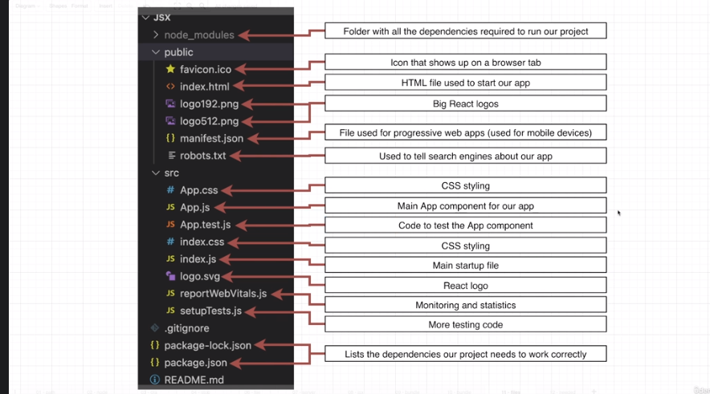

The files present in react and their use.

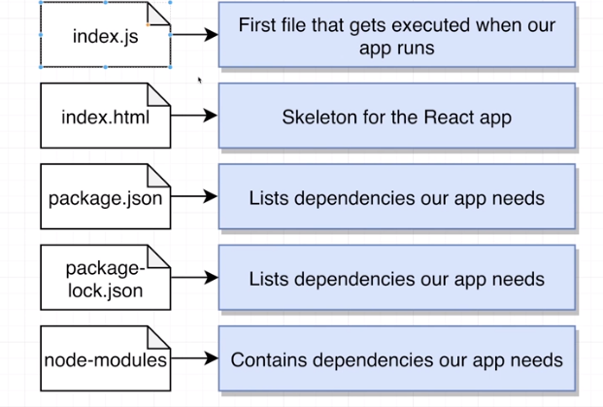

The necessary files required to run a react app